Project Design Phase-II
Data Flow Diagram & User Stories

Date | 28 January 2026
Team ID | LTVIP2026TMIDS90862
Project Name | Prosperity Prognosticator: Machine Learning for Startup Success Prediction
Maximum Marks | 4 Marks

Data Flow Diagrams:
A Data Flow Diagram (DFD) is a graphical representation that illustrates how data moves through a system. It shows the input provided by the user, the processing performed by the system, data storage components, and the final output generated.
Example: DFD level 0(IndustryStandard)
Example: (Simplified)
Guidelines:
Include all the processes (As application logic / Machine Learning and Flask Technology Block)
Provide infrastructural demarcation (Local Flask Server / Cloud Deployment if applicable)
Indicate external interfaces (Python libraries such as Scikit-learn, Pandas, Joblib, etc.)
Indicate Data Storage components / services (CSV dataset files and saved .pkl model file)
Indicate interface to machine learning models (Integration of trained Random Forest model with Flask application)
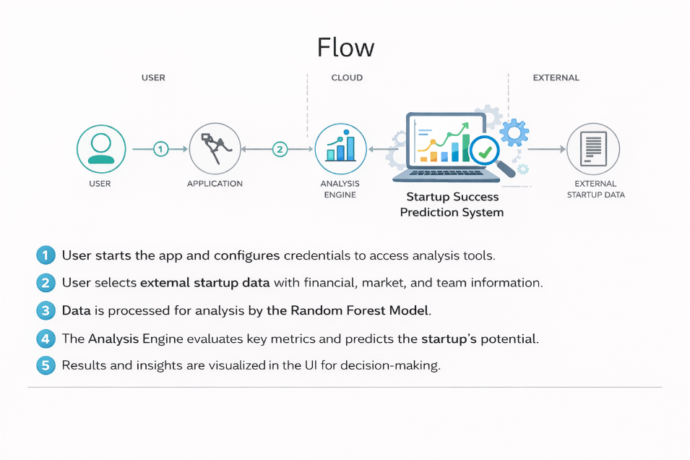

User Stories
The following section lists the user stories for the Startup Success Prediction system
User Type: Investor / Entrepreneur (Web User)
User Type | Functional Requirement (Epic) | User Story Number | User Story / Task | Acceptance Criteria | Priority | Release
Investor / Entrepreneur | Registration | USN-1 | As a user, I can register for the startup prediction system using email and password. | User account is successfully created and dashboard is accessible. | High | Sprint-1
Investor / Entrepreneur | Login | USN-2 | As a user, I can log into the system using valid credentials. | User is redirected to the prediction dashboard after login. | High | Sprint-1
Investor / Entrepreneur | Startup Data Input | USN-3 | As a user, I can enter startup details such as funding, team size, and market information. | System accepts valid input data for prediction. | High | Sprint-1
Investor / Entrepreneur | Prediction | USN-4 | As a user, I can get prediction results indicating whether the startup will succeed or fail. | System displays prediction result with success/failure label. | High | Sprint-1
Investor / Entrepreneur | View Results | USN-5 | As a user, I can view prediction probability and analysis summary. | Prediction probability score is displayed clearly. | Medium | Sprint-2

User Type | Functional Requirement (Epic) | User Story Number | User Story / Task | Acceptance Criteria | Priority | Release
Administrator | Dataset Management | USN-6 | As an admin, I can upload and manage startup datasets. | Dataset is stored successfully in the system. | High | Sprint-1
Administrator | Model Management | USN-7 | As an admin, I can retrain or update the Random Forest model. | Updated model is saved and available for predictions. | Medium | Sprint-2

